*Florida International University*

*School of Computing and Information Sciences*

Software Engineering Focus

Feature Document

User Story ID <NVOS-4 Display Results>

**Name:** Bryan Bastida

**Team Member(s):** Bryan Bastida

Andrew Castillo

**Project:** Envo Scholar

**Product Owner(s)**: Mark Finlayson

**Mentor(s)**: Masoud Sadjadi

**Instructor**: Masoud Sadjadi

**User Story Name:** Display Results

* Description: As a user, I want to receive the results from a query input, so that they are able to view the articles related to my search query.

Acceptance Criteria

* User has written out search query and pressed the search button
* A new page is opened to display results
* Database has retrieved articles according to the search criteria and displayed them on the screen

**Use Case**

* **Name**: Display Results
* **Actor**: User and Database
* **Preconditions**: User has written out search query and pressed the Search button
* **Postconditions**: Results are displayed to the screen
* **Description** <Flow of events>:
  + User types a search query into search bar
  + User clicks the Search button
  + Database uses sementic search algorithm to obtain related articles
  + Each article is diaplayed to the screen along with buttons for View PDF, View

Statistics, and Cite

**Use Case Diagram**

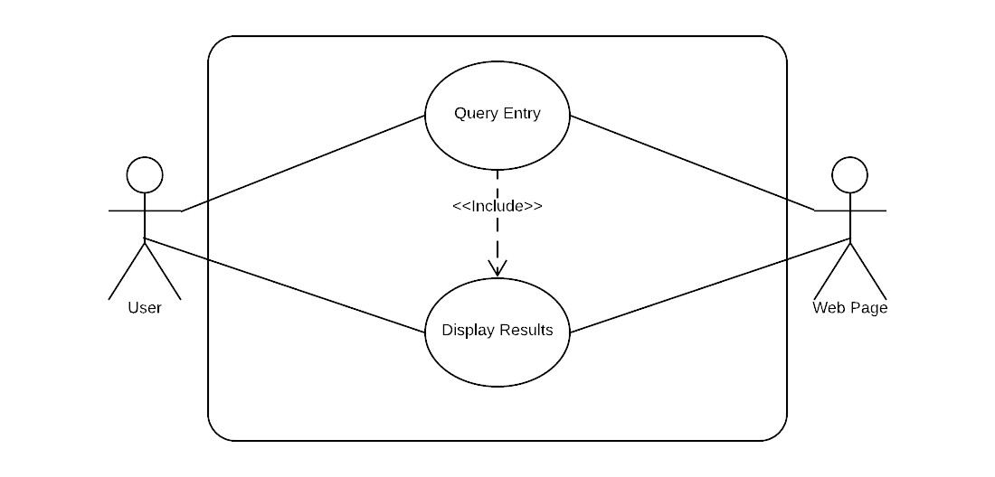

**Sequence Diagram**

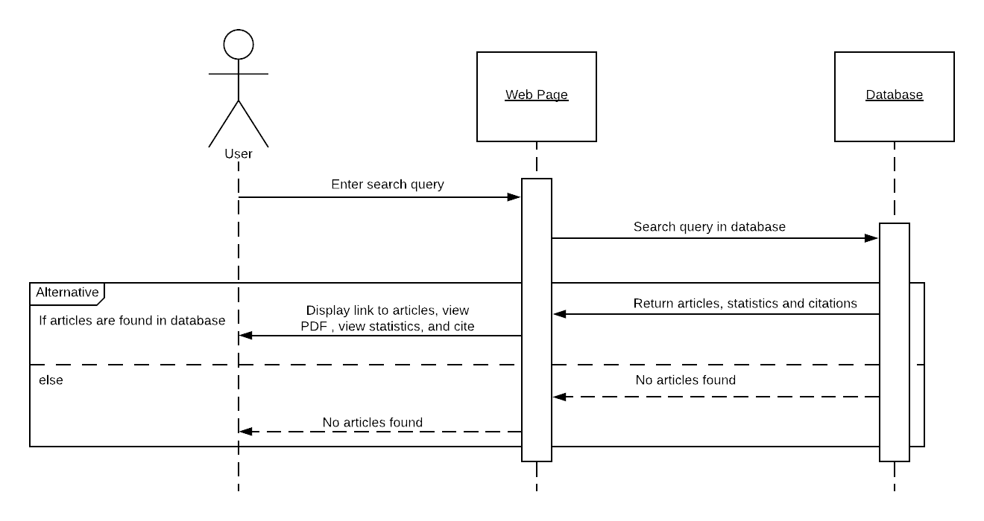

**Class Diagram**

­­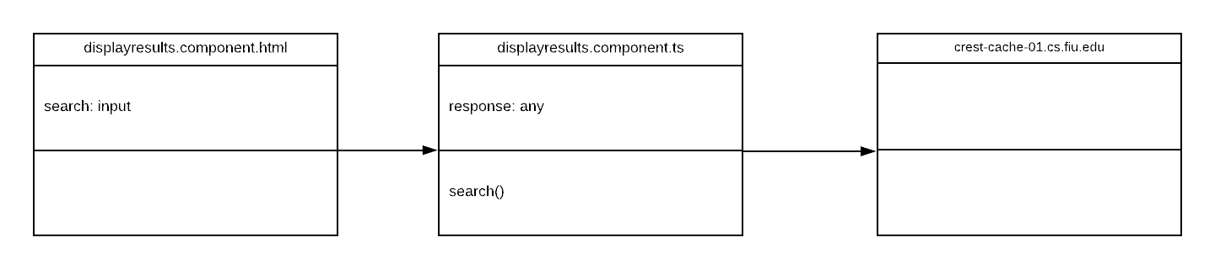

## ****Unit Test****

* Test case ID: NVOS-3-Display-Results
* Description/Summary of Test: User has entered a search into the search box and the display page loads the related articles
* Pre-condition: User is either on the home page or in the display results page. User has entered a search query. User has submitted the search.
* Expected Results: Articles related to the search will appear on the screen.
* Actual Result: Articles related to the search will appear on the screen.
* Status (Fail/Pass): Pass

**Visual User Guide (work in progress)**

